**ASSIGNMENT 9 – Introduction to React Native**

**Code :**

<https://github.com/hemapunniakotti/ReactProjects/tree/main/Assignment9_TodoReactNativeApp>

**Steps :**

We need to install Expo on our npm

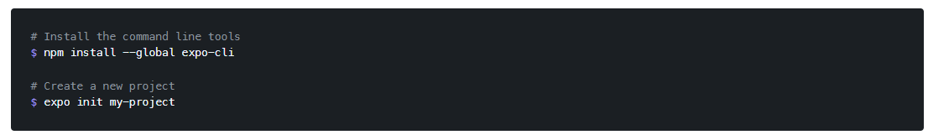

And when it’s installed we create our project with the command “expo init TODO-App”

Also, we need to download the Expo go on our devices so we can run the apps.

<https://expo.io/client>

React Native has a quite similar structure as React as we can see.

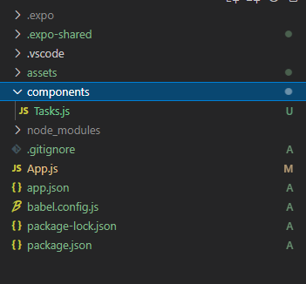

You can work on App.js like always an create components on a folder for components.

To run the app, you need to type on your cmd “expo start”

On your browser it will open this page and with your mobile app you can scan the QR code and start running your app on your device, or you can sun in web browser or on simulators.

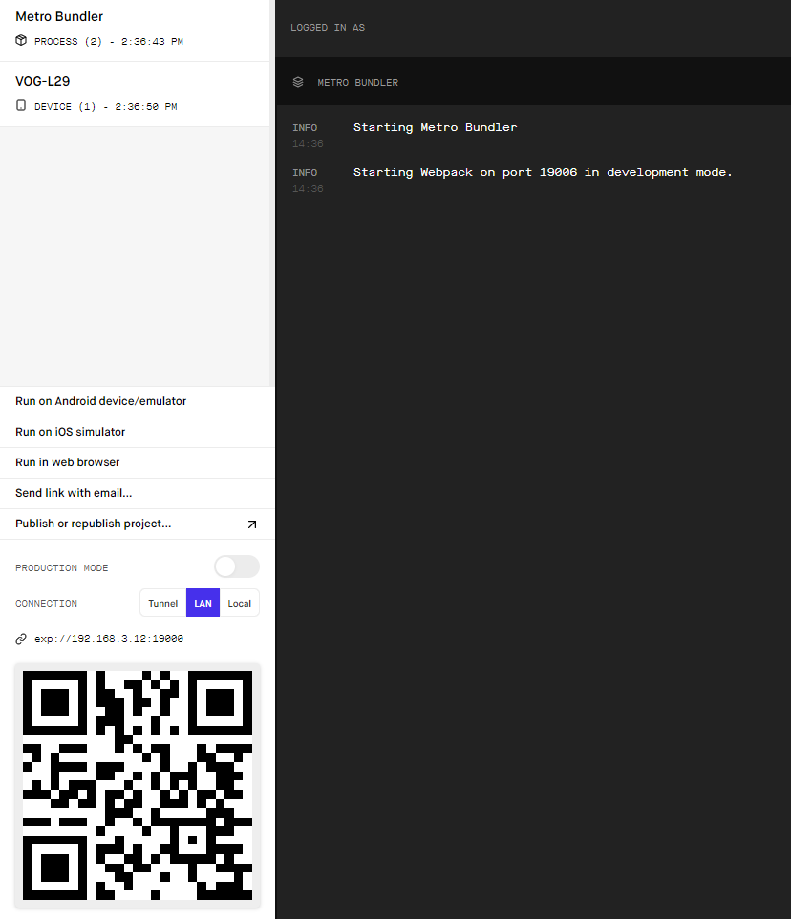

**Output :**

Here we have a simple app where it has a text input and a button to create tasks

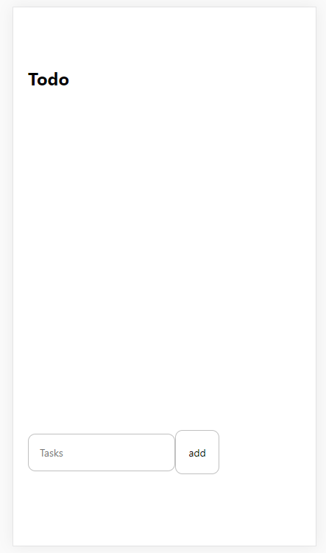

It displays all the tasks that we are adding.

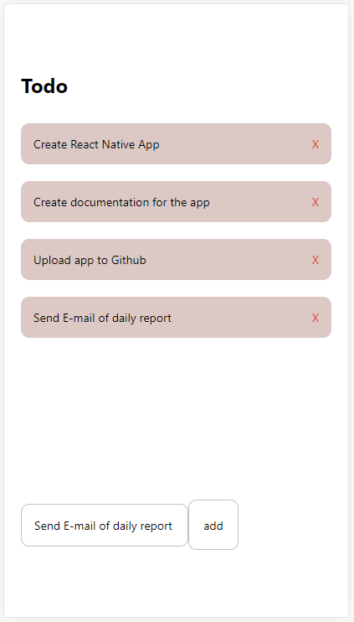

And of course, we can delete a task when is completed.

